1. What are stateless components and Demonstrate a example.
2. Demonstrate with an example, How do you pass data from child to parent component.
3. What is Context in React. Write an example to illustrate it.
4. Using react create the below form and on Submit show an alert with the inputted values.

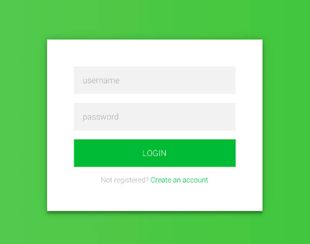

Note: Use <https://codesandbox.io/> for coding and share the links after you finish. You have 1 hour time to finish the above tasks.